

<Receipt Robot>

Process Definition Document (PDD)



Document History

| Date | Version | Name | Organization | Role | Doc Status |
| --- | --- | --- | --- | --- | --- |
|  | 1.0 | *Gregory O. Offodum* |  |  | Initial Draft |
|  | 1.1 | *Gregory O. Offodum* |  |  | Version 1 |
|  | 1.2 |  |  |  |  |
|  |  |  |  |  |  |
|  | 2.0 |  |  |  | Final Approved Version |

<<The purpose of this section is to keep track for changes. Whenever you are modifying any part of the document, please start by adding a new row in the table above>>

Contents

Introduction **3**

Purpose of the document 3

Objectives 4

Process key contacts 4

Minimum Prerequisites for automation 4

As IS process description **4**

Process Overview 4

Applications used in the process 5

As IS Detailed Process map 6

Additional sources of process documentation 6

Document Approval **7**

## Introduction

### Purpose of the document

The Process Definition Document outlines the business process chosen for automation using UiPath Robotic Process Automation (RPA) technology.

The document describes the sequence of steps performed as part of the business process, the conditions and rules of the process prior to automation. This specifications document serves as a base for developers, providing them with the details required for applying robotic automation to the selected business process and for the team to capture the knowledge to assure business continuity.

<< No need to add additional details to this section if you are not using this document for other purposes >>

### Objectives

The process that has been selected for RPA is one of many routine tasks conducted within the organization. *Receipt Robot* aims to automate transcription of receipts in pdf formats.

The business objectives and benefits expected by the Business Process Owner after automation of the selected business process are:

<<This section refers to the objectives of the automation. Please add the benefits from the Business case. If the project is part of a greater initiative please feel free to detail on that.>>

### Process key contacts

| *Role* | *Name* | *Contact details*  *(email, phone number)* | *Notes / Role* |
| --- | --- | --- | --- |
| ***Process SME*** |  | *N/A* | *Business Analyst* |
| ***Process Reviewer /*** | *Gregory O. Offodum* | *gregoryoffodum@gmail.com* | *Main Developer* |
| ***Process Owner/ Approver for production*** |  | *N/A* | *General Manager* |

*<<The table above is to clarify the people actively working on the project. SME stands for Subject Matter Expert, the person with the most experience in running the process. The reviewer is usually a second pair of eyes with experience on running the process as well. The process Owner is the one responsible for the outcome of the process. >>*

### Minimum Prerequisites for automation

1. Filled in Process Definition Document
2. Credentials (user ID and password) required to logon to machines and applications
3. Test Data to support development.

<<Besides the points above please add here all the other prerequisites for automation. Please take into account that we are usually going to work outside your premises therefore you can consider a virtual Machine for ex.>>

## As IS process description

### Process Overview

General information about the process selected for RPA prior to automation.

| # | Item | Description |
| --- | --- | --- |
| 1 | **Process full name** | *Receipt Robot* |
| 3 | **Department** | *Accounting* |
| 4 | **Process short description**  (operation, activity, outcome) | *Transcribing pdf receipts to excel formats using split or regular expression methods* |
| 5 | **Role(s) required for performing the process** | *Google account, Yahoo account, Credentials XYZ.* |
| 6 | **Process schedule and frequency** | *Daily* |
| 7 | **# of items processes /month** | *4000* |
| 8 | **Average handling time per item** | *3 seconds/item* |
| 9 | **Peak period (s)** | *TBD* |
| 10 | **Total # of FTEs supporting this activity** | *22* |
| 11 | **Level of exception rate** | *4 (on a scale of 1 -10)* |
| 12 | **Input data** | *Structured pdf* |
| 13 | **Output data** | *Excel format* |

### Applications used in the process

The table includes a comprehensive list all the applications that are used as part of the process automated, at various steps in the flow.

| # | Application name & version | System  Language | Login Module | Interface | Environment/  Access method | Comments  (Include URLs) |
| --- | --- | --- | --- | --- | --- | --- |
| 1 | Receipt Robot 1 | TBD | TBD | TBD | TBD | TBD |
| *2* | *App 2* | TBD | TBD | TBD | TBD | TBD |

<<Those are all the applications in which the robot will need to have access and work on >>

### As IS Detailed Process map

*<<Please add here a detailed process map of the process. If you do not have access to a process mapping system you can use* [*www.draw.io*](http://www.draw.io) *The map needs to be at the highest level of detail>>*

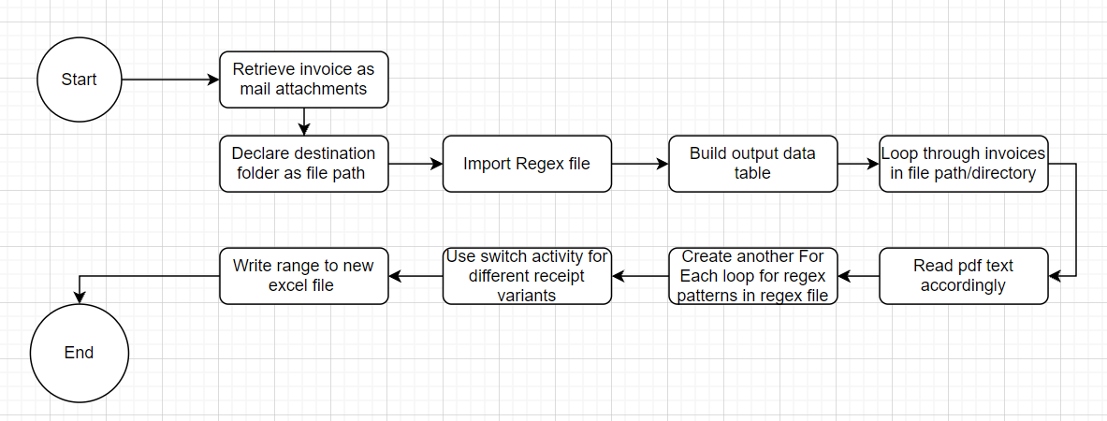

### As Is Detailed process steps (with print screens)

<<All the steps from the process map need to be detailed in this section at a click level with print screens attached.>>

Steps:

1. Retrieve receipt attachments from email
2. Declare file path and import receipt
3. Import regular expressions pattern file
4. Build output data table with desired column names
5. Loop through invoices in directory
6. Read pdf text to string accordingly
7. Loop through regular expressions inside loop in 5
8. Use Switch activity to select cases for different receipt variants
9. Add row after
10. Write range to output excel file

## Document Approval

This document requires serial approval (sign off) from the roles defined in the table below.

Changes to the requirements must be documented in an updated version (i.e v 2.0) and requires a new signature flow.

| Role | Name | Organization  (Dept.) | Approval Date: |
| --- | --- | --- | --- |
| ***Business Analyst*** |  | *TBD* | *TBD* |
| ***SME*** |  | *TBD* | *TBD* |
| ***Process Owner (Manager)*** |  | *TBD* | *TBD* |
| ***IT*** |  | *TBD* | *TBD* |